1. A company wants to know when they raise their prices if they will lose customers. Therefore, they complete a satisfaction survey with new customers to see if new customers would drop the service with the price increase. At the normal price, satisfaction is 4.0 points with a standard deviation of 1.2 points. After the price increase, satisfaction scores are as follows: 3, 4, 3, 4, 2, 1, 5, 3, 2, and 3. Using the p<.05 level, is this a significant drop in price?
   1. Stat > z statistics > one sample > with data
   2. Enter the standard deviation (1.2)
   3. Enter the population mean (4.0)
   4. Enter the type of test (<)

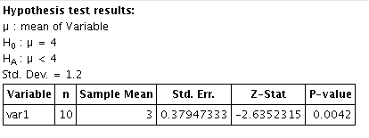

Real answer:

|  |
| --- |
| Res: new price < old price satisfaction  Null: new price > = old price satisfaction |
| U = 4.0  M = 3.0  O = 1.2,  Om = .38 |
| Less than test with p<.05 = -1.64 |
| -2.64 |
| Reject! |

1. 50 dogs were tested in a new dog-training program. They had an average obedience score of 5.6 after the dog-training program. The old dog-training program had an average score of 3.4 and standard deviation of 2.5 before they switched to the new program. Is there a significant increase in their program using the .01 significance level?
   1. Stat > z statistics > one sample > with summary
   2. Enter the sample mean 5.6
   3. Enter the standard deviation 2.5
   4. Enter the sample size 50
   5. Enter the population mean 3.4
   6. Enter the type of test >

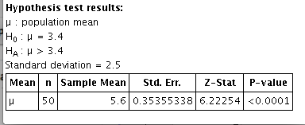

|  |
| --- |
| Res: new program > old program  Null: new program < = old program |
| U = 3.4  M = 5.6  O = 2.5  Om = .35 |
| Greater than test with p<.01 = +2.33 |
| 6.22 |
| Reject! |

1. Netflix incorporated a new rating system to see how accurately they could predict your rating for new shows. They normally are within 1 point of your score with a standard deviation of 1.35. The new system is within .5 points of your score, after testing on 100 people. Is this a significant difference in scoring using the p<.05 significance level?

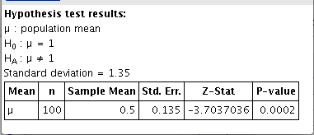

|  |
| --- |
| Res: new rating system /= old rating system  Null: new rating system = old rating system |
| U = 1  M = .5  O = 1.35  Om = .14 |
| Difference test with p<.05 = +- 1.96 |
| -3.70 |
| Reject! |

1. 10 students were tested on a new language learning program: 75, 60, 90, 95, 70, 80, 60, 65, 70, and 75. The normal score is 85% with a standard deviation of 14.2%. Is the student’s score statistically lower than normal using the p<.01 significance level?

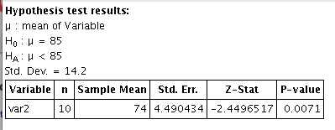

|  |
| --- |
| Res: language program < old language program  Null: language program > = old language program |
| U = 85  M = 74  O = 14.2  Om = 4.49 |
| Less than test with p<.01 = -2.33 |
| -2.44 |
| Reject! |